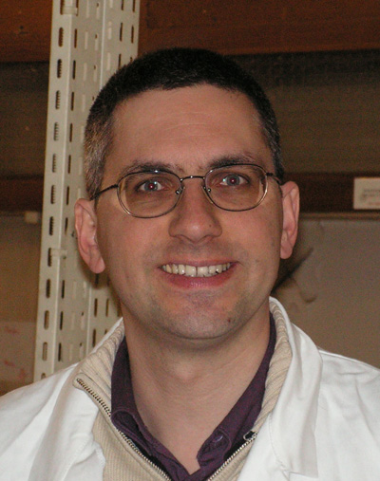 **Johannes Richardi**

**Associate professor**

Laboratoire MONARIS

Sorbonne Universités UMR CNRS-UPMC 8233   
UPMC, case 52, place Jussieu 75252 Paris Cedex 05

Tél : 33 1 44 27 25 73, e-mail [johannes.richardi@upmc.fr](mailto:johannes.richardi@upmc.fr)

Married, one child

TOPICS OF RESEARCH

***Multi-scale Modelling of nanoparticles***

**A. Atomistic simulations of nanoparticles: from the atom to the nanoparticle**

Aim: understanding the differences between the bulk and the nano

Systems: gold and silver nanocrystals coated by thiolates

Methods: Molecular dynamics and Monte Carlo at atomic level, massive parallelism, DFT

**B. Simulation of nanoparticle assembly: from one nanoparticle to thousands**

Aim: using nanoparticles as LEGO bricks

Systems: supercrystals made of gold, silver, maghemite and cobalt nanoparticles

Methods: Molecular dynamics and Monte Carlo at atomic and particle level, Flory-type solubility theories

**C. Theory of mesostructures made of magnetic nanoparticles:** **from 100 nm upward**

Aim: understanding and prediction of new mesostructures

Systems: patterns made of cobalt and maghemite nanoparticles, cracks in nanoparticle films, super spin and spin glasses

Methods: free energy approaches, Brownian dynamics and Monte Carlo simulations at particle level, bundle-spring block models for cracks, parallel tempering

ACADEMIC APPOINTEMENT

since 1999 Maître de conférences at UPMC (associate professor)

VISITING ACADEMIC APPOINTEMENT

1998-1999 Commissariat à l’Energie Atomique, Grenoble, France (Marie Curie fellow)

1997 Université Henri Poincaré, Nancy, France (invited professor)

DIPLOMA

2008 Habilitation at UPMC

1997 Thesis at the University of Regensburg, Germany (mark: summa cum laude)

1993Diploma of chemistry at the University of Regensburg (mark:1.1 – very good)

CRCT AND DELEGATIONS AT THE CNRS

2010-2012 2 delegations at the CNRS:

2008-2009 CRCT (sabbatical year for research)

PRICES

2016 best communication at the EMRS 2016 (Warsaw, Poland).

1997 best communication at the European Research Conference on Molecular Liquids (Crete)

1996 best communication at the *Molecular Liquids Group Meeting* (Hungary)

PUBLICATIONS (H factor: 20)

50 publications in international journals (Nature Materials, Nanoletters, Physical Review Letters, Chemistry of Materials…)

10 invited lectures

14 oral communications in national and international meeting

Since 2016: 10 invitations for lectures on conferences in Europe and USA

ORGANIZATION OF CONFERENCES

WORKSHOP "Crack Patterns in Various Systems", 23/01/2012, Paris

WORKSHOP "Surfaces et Nanoparticules : Théorie et Expériences", 27/10/2014, Paris

INTERNATIONAL SYMPOSIUM "Theory of magnetic nanoparticle assemblies", 30/03/2017, Paris

Member of organizing committee of **CHITEL 2017** ([XLIII Congress of Theoretical Chemists of Latin Expression](http://chitelparis2017.sciencesconf.org)), 3-7/07/2017, Paris

FUND RAISING

* 2014 LABEX MICHEM postdoc position "Towards accurate force fields for nanocrystals" (Responible of project)
* 2014 ANR DisCo-Hall (responsible: Sawako NAKAMAE, CEA Saclay)
* 2015 ANR MACALON (responsible: Isabelle LISECKI, UPMC)

COLLABORATIONS

* Anh-Tu Ngo, Isabelle Lisiecki, Alexa Courty (University Pierre et Marie Curie)
* Jean-Jacques Weis (University d’Orsay - Paris 11)
* Massimo Marchi, Stéphane Abel (CEA Saclay)
* Jean-Philip Piquemal, Monica Calatayud (University Pierre et Marie Curie)

DIRECTION OF RESEARCH

2003 Co-direction of the master of Adrien Fuchs

2004 Co-direction of the phd thesis of Yoann Lalatonne

2005 Co-direction of the phd thesis of Vincent Germain

2011 Direction of the phd thesis of Takieddine Djebaili

2016 Direction of the phd thesis of Clément Dolong (with Bruno Madebène, Monaris)

2017 Co-direction of the master of (with Vincent Russier, CNRS)

ADMINISTRATION RESPONSABILITIES

2005-2013 Responsible for informatics at LM2N

Since 2014 Co-Responsible for informatics at MONARIS

2009-2010 Member of the council of the Institut des Matériaux de Paris Centre

2011-2014 Member of the council of IP2CT

2011 Member of the scientific committee of chemistry at UPMC

Since Member of the council of MONARIS

TEACHING RESPONSABILITIES

2002-2010 coordinator of LC101

Since 2014 Responsible of "Introduction à la programmation scientifique" with R. Veuillemier (3rd year of Licence)