**SUBJECT: MULTISCALE MODELING OF NANOPARTICLES**

Our aim is the study of nanoparticles using statistical mechanics to understand their properties, discover new ones and find potential applications. All studies are carried out with program codes developed in our laboratory.

This work is done in close contact with quantum chemists, experimentalists and industrial partners.

**A. Atomistic simulations of nanoparticles: from the atom to the nanoparticle**

Our multiscale approach starts with Molecular Dynamics and Monte Carlo simulations at an atomic scale. We study the growth of metallic nanoparticles and their protection by ligands which adsorb on the nanoparticles surface. The specific aim here is to better understand the differences between the bulk and the nano.

**Studied systems:** gold and silver nanoparticles protected by alkane thiolate

**Major results:**

* simulation of nanoparticles up to 10 nm using massively parallel computation (largest nanoparticles simulated ever),
* prediction of density of ligands on the nanoparticle in agreement with experiment,
* discovery of a new molecular assembly of ligands on the nanoparticle edges (see Figure 1).

**Home-made programs:** NATOMOS (Nanoscale atomistic optimized simulations)

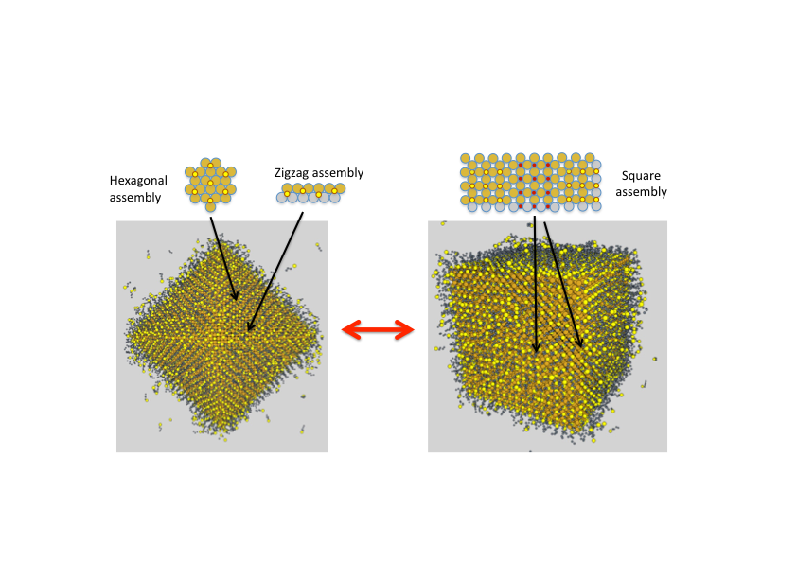

**Figure 1.** Simulation snapshots of gold nanocrystal protected with alkanethiolates for octahedral and cubic form. The sketches show the assemblies observed (the small red and yellow circles indicate the positions of the S groups). For octahedra, a new zigzag assembly is observed on the edges.

**B. Simulation of nanoparticle assembly: from one nanoparticle to thousands**

Here, we try to understand the ways nanoparticles self-assemble using Molecular Dynamics and Monte Carlo simulations at atomic and particle level. A Flory-type solubility theory based on Hansen parameters is used to obtain the forces between nanoparticles. The specific aim is to be able to build larger structures using nanoparticles such as LEGO bricks.

**Systems:** supercrystals made of gold, silver, maghemite and cobalt nanoparticles

**Major results:**

* prediction of the distance between nanoparticles in agreement with theory and experiments (see Figure 2),
* discovery of the importance of solvents for nanoparticle assembly,
* prediction of nanoparticle size as a function of the solvent in perfect agreement with experiment (prize for best communication during the EMRS 2016).

**Home-made programs:** NATOMOS, NanoForceX (computation of nanoparticle interactions), BDYNB (Brownian dynamics simulation at particle level)

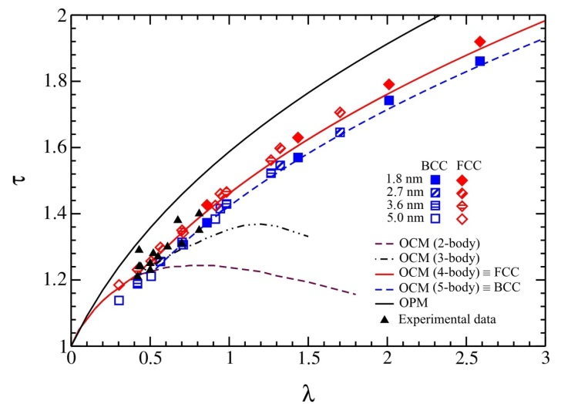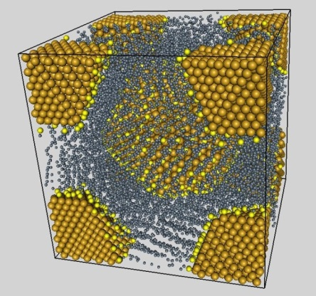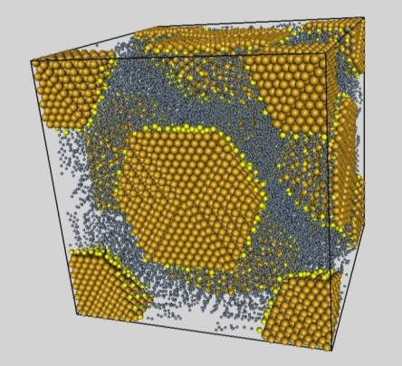

**Figure 2.** Simulation snapshots of fcc and bcc assembly of gold nanocrystals. Right panel: Nanoparticle distance as a function of ligand size.

**C. Theory of mesostructures made of magnetic nanoparticles:** **from 100 nm upward**

Finally, the assemblies of nanoparticles can be used to create structures or spin orientations on a mesoscale. Our aim here is to understand their appearance and predict new mesostructures. These systems are studied by free energy approaches, Brownian dynamics and Monte Carlo simulations at particle level, bundle-spring block models for cracks, parallel tempering. These projects are partly carried out with an industrial partner.

**Systems:** patterns made of cobalt and maghemite nanoparticles (columns, chains, labyrinths) cracks in nanoparticle films, super spin and spin glasses

**Major results:**

* Explanation of pattern formation (Nature Materials),
* discovery of two new patterns (ellipsoidal and circular voids, Physical Review Letters, see Figure 3),
* discovery of scaling law for crack distances (Nanoletters),
* 2 ANR projects financed since 2015.

**Written programs:** BDYNB, CRACKT (crack simulations), HEXALAB (free energy approach for magnetic patterns)

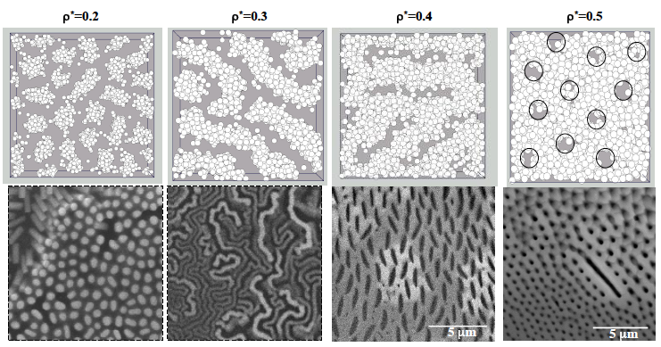

**Figure 3.** Mesostructures observed by Monte Carlo simulations (first line) et experiments (2nd line) as a function of the density.

**These three subjects are strongly connected.** Thus, the correct description of the nanocrystals obtained in A is used in the atomistic simulations of nanoparticle assembly. The interaction potentials between nanoparticles obtained in B are used in the simulation of pattern formations in C.

**What is next?**

**Concerning A.** We need better interaction models for the atoms. We propose to obtain them by a unified approach using DFT calculation on small clusters and metallic surfaces. In particular, we will try to develop polarizable force fields (about 20 % of the interaction between ligands and metallic nanoparticles is due to polarization). We will combine NATOMOS and TINKER HP, which will enable the large community of TINKER to carry out simulations on nanomaterials using massively parallel computations. We also want to apply these methods to new materials: cobalt, copper, maghemite. There are many differences observed experimentally between these nanoparticles which are not yet understood.

**Concerning B.** We need better interaction models for the nanoparticles. We aim to carry out atomistic simulations to obtain the potential of mean force between two nanoparticles in a solvent. We also want to make NanoForceX an application available on any computer and cell phone and continue to improve it (non spherical particles, biological ligands, …). This would it make a valuable tool for all scientists which synthesize, assemble nanoparticles and develop applications.

**Concerning C.** We need more simulations to correctly predict the spin states in magnetic nanoparticle assemblies. Our current aim is to find a super-spin sate where all magnetic dipoles show in the same direction. This depends on many factors (nanoparticle characteristics, shape of nanoparticle assemblies, …). The discovery of this new state would be a major progress in our field with many potential applications.